

Student Success Plan
Student Name: Today’s Date:
When starting your Student Success Plan, consider your career competency self-assessment scores, along with your career aspiration, to determine which competencies you will prioritize developing this semester; for example, you may prioritize events focused on Oral & Written Communication and Digital Technology based on your scores and your career interest in being a Marketing & Communications professional.
Consider scheduling subsequent coaching sessions to further uncover your motivations to succeed and your level of confidence to land your dream job and enjoy the career you’ve always wanted.
Career Competency Self-Assessment Scores:
Initial Score/Subsequent Score Initial Score/Subsequent Score
CRITICAL THINKING & PROBLEM SOLVING:
ORAL & WRITTEN COMMUNICATION:
DIGITAL TECHNOLOGY:
TEAMWORK & COLLABORATION:
LEADERSHIP:
EQUITY & INCLUSION:
CAREER DEVELOPMENT:
PROFESSIONALISM & WORK ETHIC:
PERSONAL WELL-BEING:

Current Career Aspiration:
What do you picture yourself doing post-graduation?

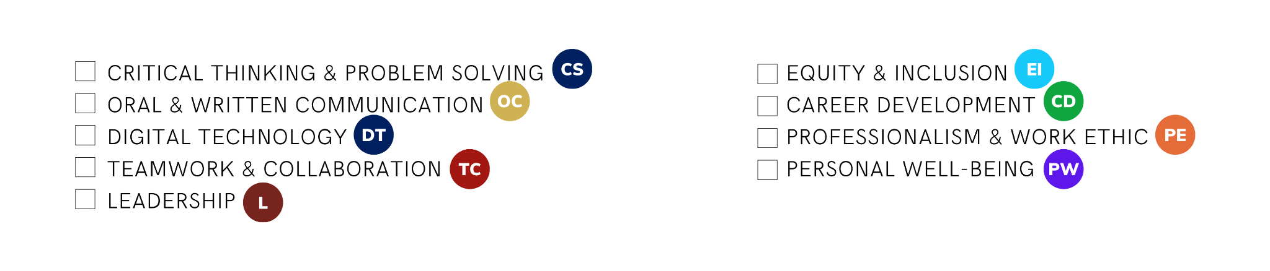
Current Career Competency Focus:
Choose TWO career competencies you are going to focus on developing this semester based on your self-assessment scores and career aspiration.

Select upcoming competency-building events or activities in Hire U:
Using your two selected career competencies as a guide, review upcoming activities or events in Hire U and select 3 or more activities or events you would like to participate in that focus on one or both of your selected competencies. Indicate below what the events or activities are, the competency focus, and the date - then add them to your calendar.

USG Event or Activity | Competencies Developed by Completing | Date
Example: Art of Professional Communication Workshop | OC & PE | 4/27 12:30P

OPTIONAL: Define your career development SMART goals:
Clearly and fully articulate your goals, and prioritize those goals in a way that is objectively measurable. Write two to three SMART goals: Specific, Measurable, Achievable, Relevant, and Time-Bound.
For example: Complete at least one career discovery activity this semester to help me determine my career path that will build on my StrengthFinders strengths, align with my desire to work in healthcare, and help me determine if I need to complete a graduate degree post-graduation.

Goal One:

Goal Two:

Goal Three:

OPTIONAL: Develop a Plan to achieve your career development SMART goals:
In this step, you will work with a career coach to develop a detailed plan that establishes a timeline for your SMART goals. This plan should consider your other time commitments, such as schoolwork, employment, family, friends, community, and other daily responsibilities. Your coach will also help you to identify the resources currently available to you, and those you may need to acquire. This will create an actionable plan that guides you from where you are today to where you want to be in the weeks and months ahead.
Your coach may also employ tools and assessments that will help you gain clarity about yourself as a professional and identify preferences in roles, occupations, and industries. These tools and assessments are designed to reveal your interests, values, and skills.

Career Development SMART Goal | Steps I will take to achieve this goal | Date Completed

Recommended activities for your 1st semester:
- Complete Hello Hire U and Student Success Plan Achievements in Hire U.
- Complete 1 of the 9 Career Competency Achievements in Hire U.
- Register for USG’s Career Connector jobs database to access our Career Center’s platform in order to schedule coaching sessions, explore internships, and search for regional jobs.
- Join a student club or organization to get involved with the student community or to explore professional interests.
- Identify activities to engage in on the USG or main campuses, at a job or internship, with community organizations, student clubs and organizations and other areas of learning that will aid in building knowledge and career readiness skills.
- Participate in career exploration activities such as Career Expos, Career Exploration panels, and Career Immersion visits.
- If you are planning to attend graduate school, register for standardized practice tests (GRE, GMAT, etc.) and begin reviewing graduate school application requirements.

Recommended activities for your 2nd semester:
- Complete 2-3 of the 9 Career Competency Achievements in Hire U.
- Meet with a Career Coach to check in about your Student Success Plan and determine next steps for this semester
- Build your brand by creating or enhancing your LinkedIn profile. Meet with a Career Coach or attend a USG LinkedIn Profile Clinic for expert advice on how to make your profile attractive to employers.
- Create or update your professional resume and begin building your professional portfolio. Meet with a Career Coach for expert guidance on how to make your resume stand out.
- Login to USG’s Career Connector to explore and identify internship opportunities which best fit your needs. Consider applying for spring or summer internships.
- Review your social media accounts with an eye towards employment. Update content to ensure it is appropriate and reflects the professional brand you want employers to see. Google yourself to monitor and continuously polish your online presence.
- Utilize Big Interview or participate in one of USG’s Mock Interview Clinics to gain valuable experience interviewing in both in- person and virtual formats. Visit the USG Career Center “event” page for information regarding Clinic dates and times.
- Gather information about summer learning opportunities like study abroad or community service projects which you can participate in.

Recommended activities for your 3rd semester:
- Complete the required number of Career Competency Achievements in Hire U to apply to the Hire U Honor Society.
- Meet with a Career Coach to check in about your Career Plan and launch your professional job search.
- Research salary and cost of living information using Glassdoor and other online resources.
- Use USG’s Career Connector and other job search tools to identify job opportunities which are a good fit for you. Begin preparing applications to include tailored cover letters, resumes, and other required documents.
- Participate in job interviews as you are invited by hiring employers. Use Big Interview or meet with your Career Coach to prepare before interviews.
- Make a list of faculty, former supervisors or others who can serve as professional references for you. Contact them to ask if they will serve as references and to verify current contact information.
- Seek a leadership position(s) with a student club or organization.
- Consider building practical experience through academic research and class projects.
- Attend Career Fairs and other employer recruiting events offered at USG or on your home campus. Take advantage of opportunities to explore current career opportunities and begin narrowing your job focus.
Recommended activities for your 4th semester:
- Meet with a Career Coach to check in about your Student Success Plan, continue your professional job search, and evaluate job offers.
- Continue attending Career Fairs and other employer recruiting events offered at USG or on your home campus. Take advantage of opportunities to identify job opportunities in your chosen industry.
- Use USG’s Career Connector and other job search tools and continue to identify job opportunities which are a good fit for you. Continue preparing and submitting applications to include tailored cover letters, resumes, and other required documents.
- Continue participating in job interviews as you are invited by hiring employers. Use Big Interview or meet with your Career Coach to prepare before interviews.
- Join professional organizations or affinity groups to meet professionals in your chosen field. Continue growing your network both in-person and virtually.
- Update your resume and LinkedIn profile to reflect your completed degree and any related honors once you have graduated.
- Join alumni organizations with USG and your home campus to stay connected after graduation.
Notes:

